**APIARY:**

**Steps:**

- Go to this link : <https://apiary.io> and create an account.

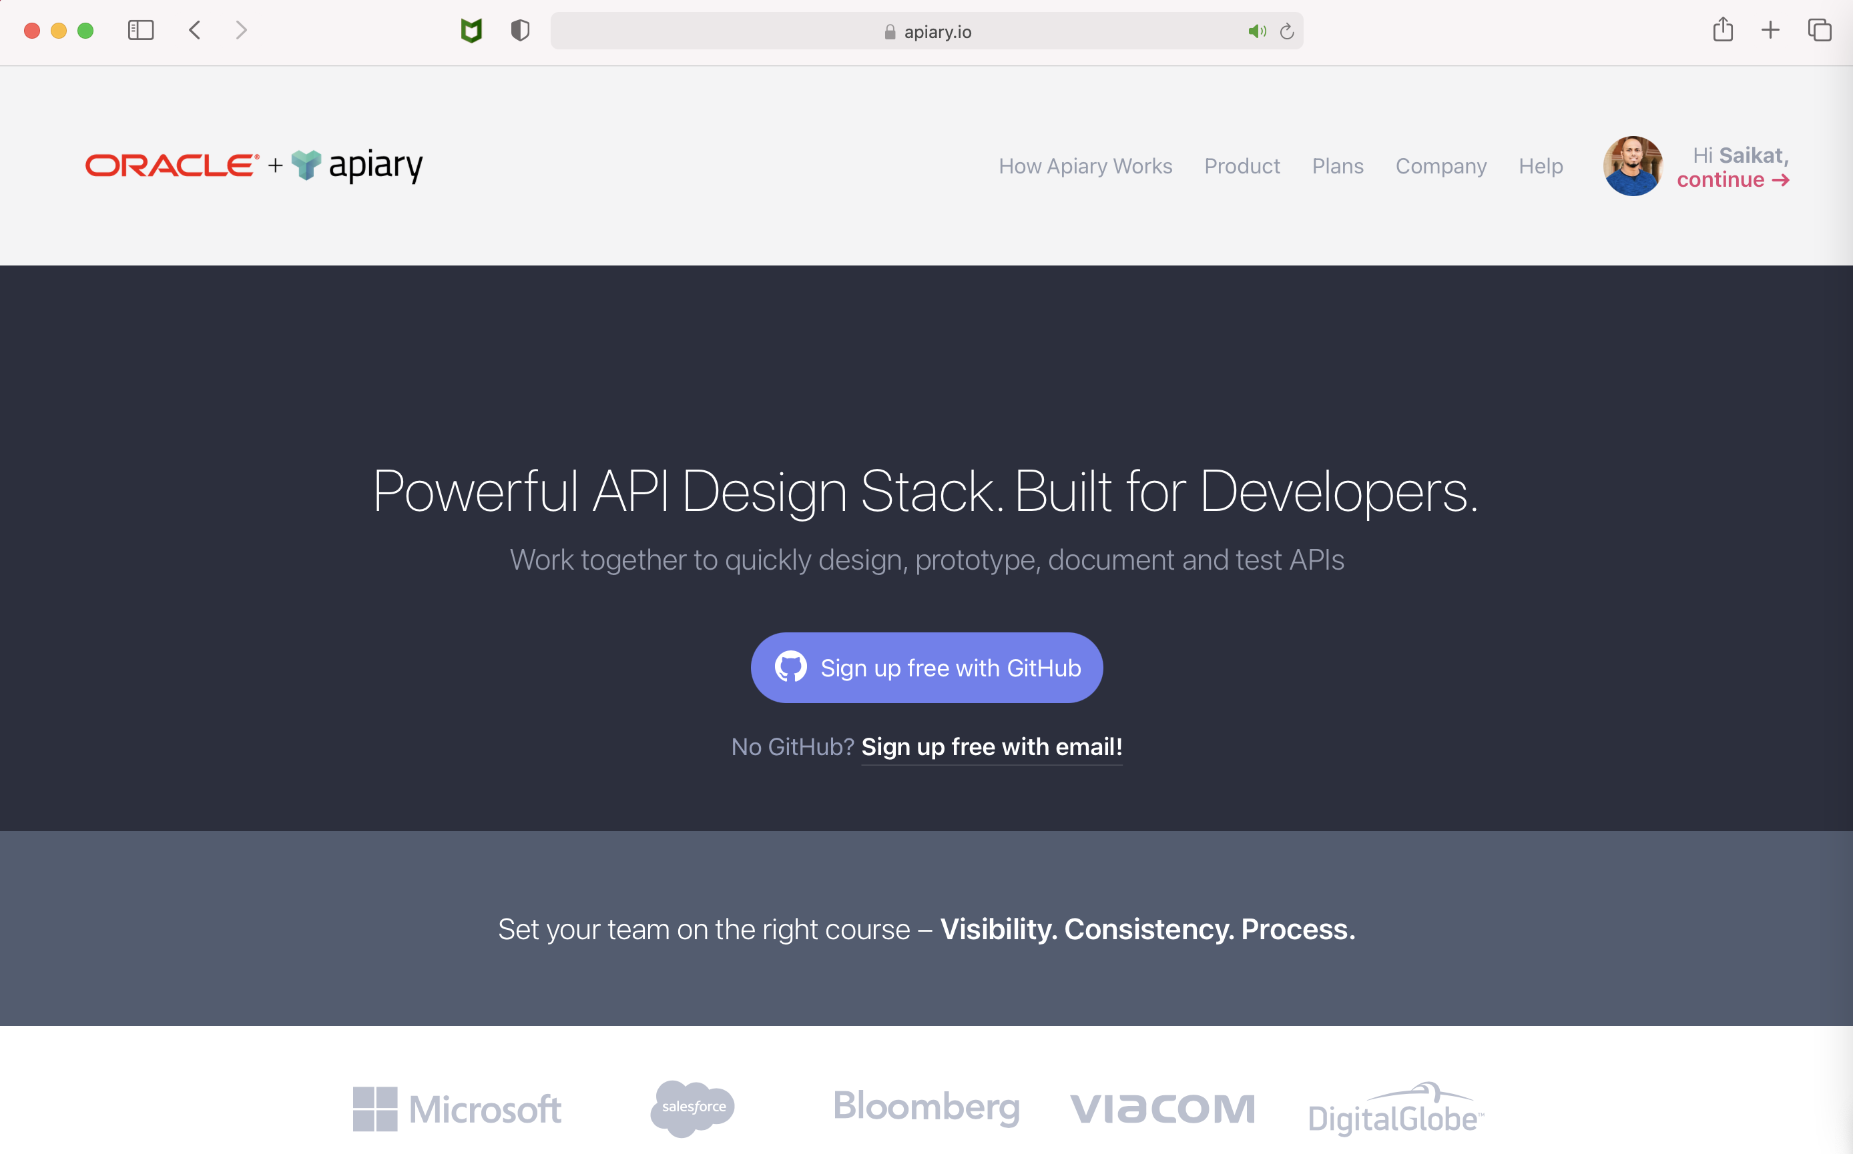

- Click on Create a new API Project

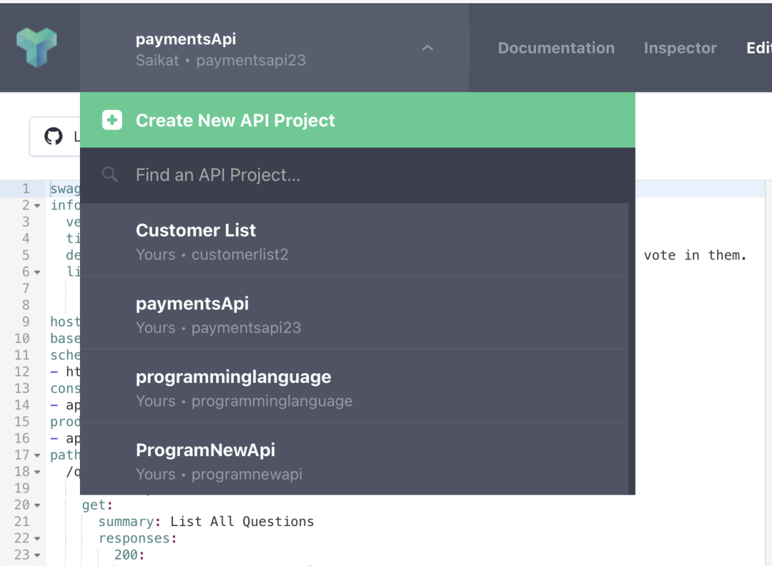

- This will open up a pop up window. Now provide a name and click Create API.

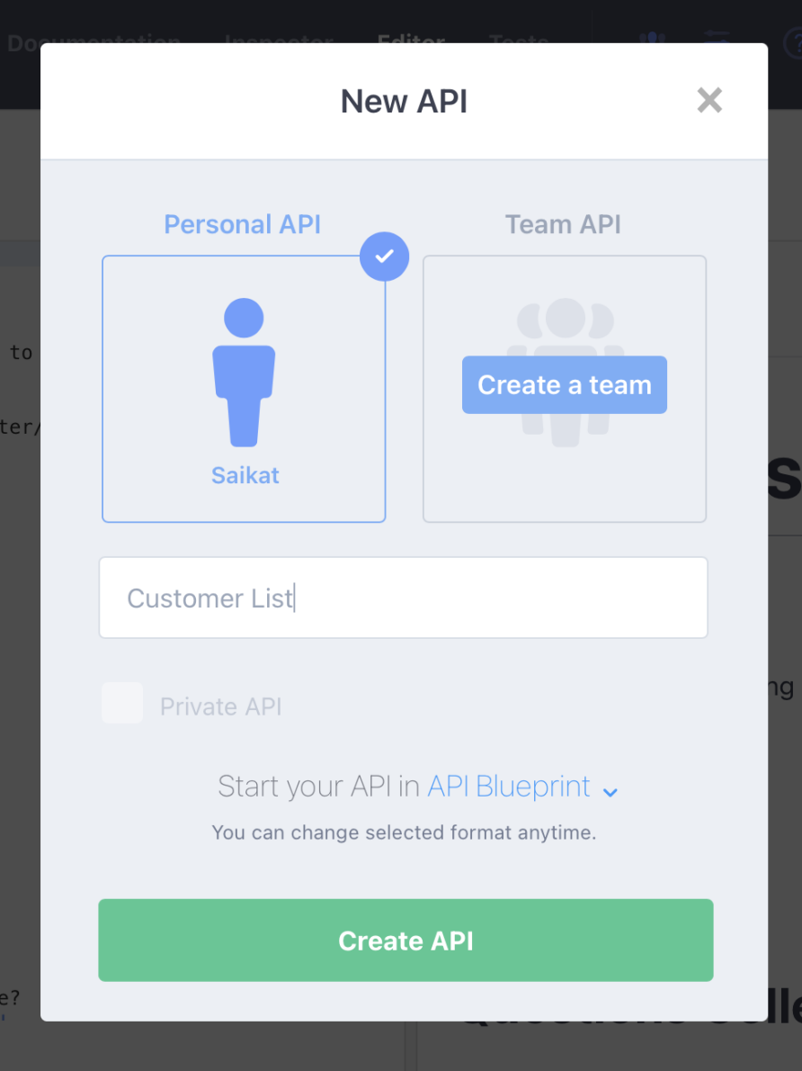

- Replace the existing code with the below code.

FORMAT: 1A

HOST: https://custlist.apiblueprint.org/

# Customer List

Get customer details

## Questions Collection [/mylist]

### List All Questions [GET]

+ Response 200 (application/json)

[

{

"id": 7,

"email": "michael.lawson@reqres.in",

"first_name": "Michael",

"last_name": "Lawson",

"avatar": "https://reqres.in/img/faces/7-image.jpg"

},

{

"id": 8,

"email": "lindsay.ferguson@reqres.in",

"first_name": "Lindsay",

"last_name": "Ferguson",

"avatar": "https://reqres.in/img/faces/8-image.jpg"

},

{

"id": 9,

"email": "tobias.funke@reqres.in",

"first_name": "Tobias",

"last_name": "Funke",

"avatar": "https://reqres.in/img/faces/9-image.jpg"

},

{

"id": 10,

"email": "byron.fields@reqres.in",

"first_name": "Byron",

"last_name": "Fields",

"avatar": "https://reqres.in/img/faces/10-image.jpg"

},

{

"id": 11,

"email": "george.edwards@reqres.in",

"first_name": "George",

"last_name": "Edwards",

"avatar": "https://reqres.in/img/faces/11-image.jpg"

},

{

"id": 12,

"email": "rachel.howell@reqres.in",

"first_name": "Rachel",

"last_name": "Howell",

"avatar": "https://reqres.in/img/faces/12-image.jpg"

}

]

- Once the new code is pasted this would look like this:

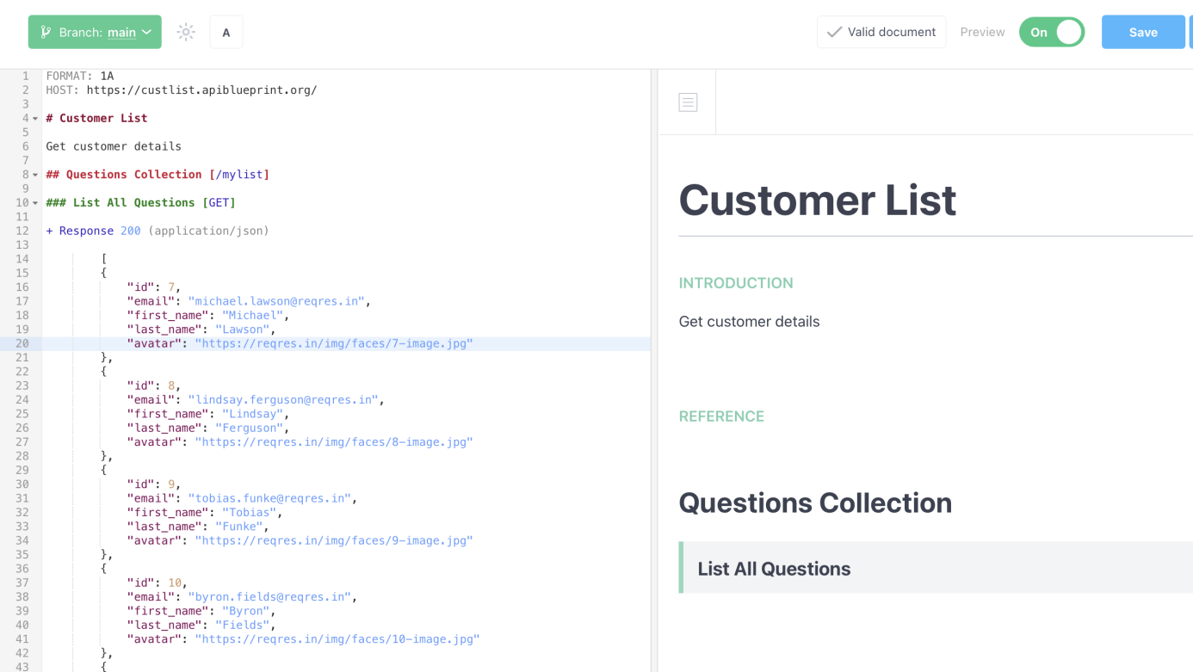

- Click on the **Save** button on the top right corner to savethe updated api code.

- Click on the List All Questions options to load the Testing Console.

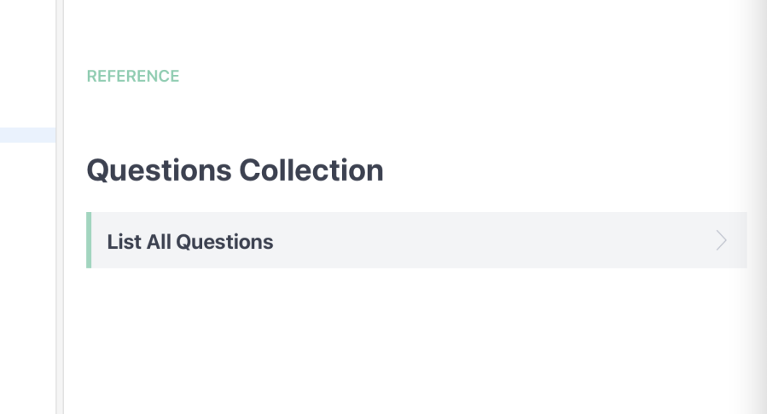

- Select the Mock Server from the list and click on “Call Resource”.

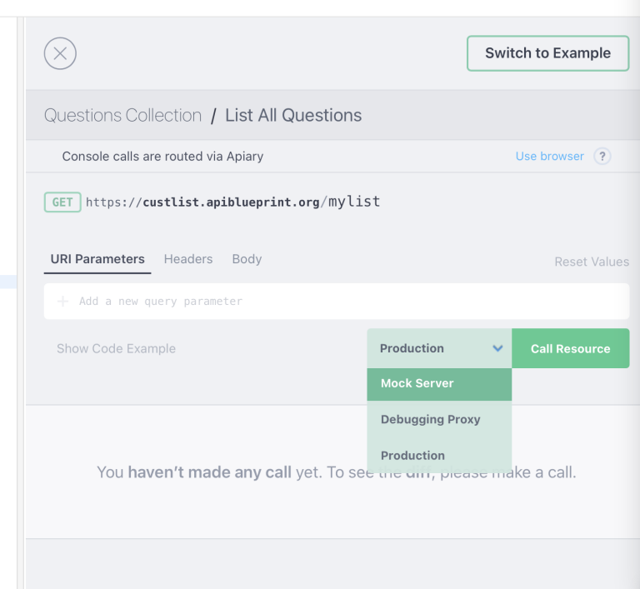

- This would display the response generated from the created API.

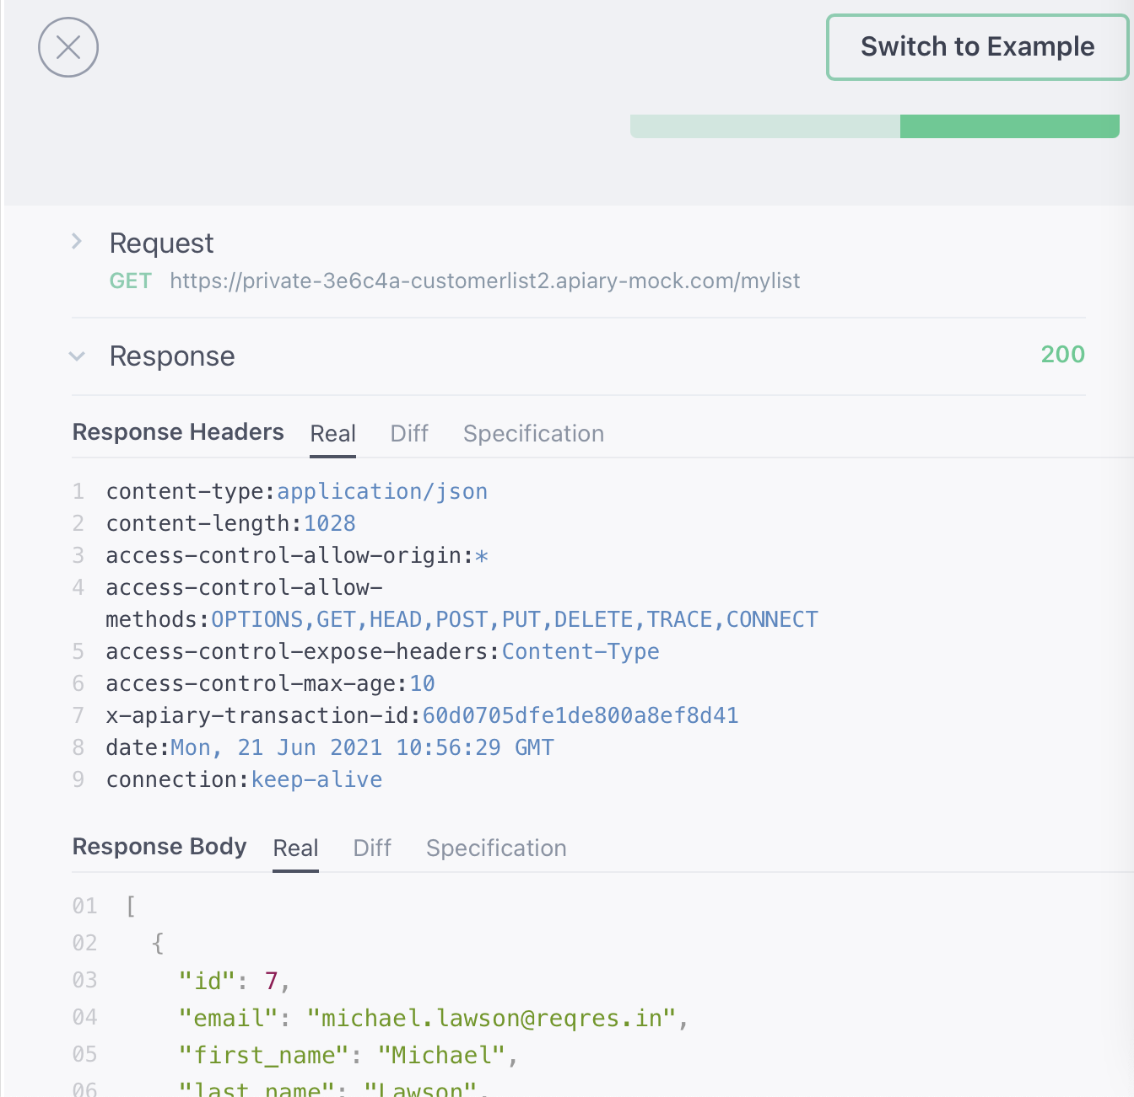

- We can also use the generated URL to test if the service is working or not.

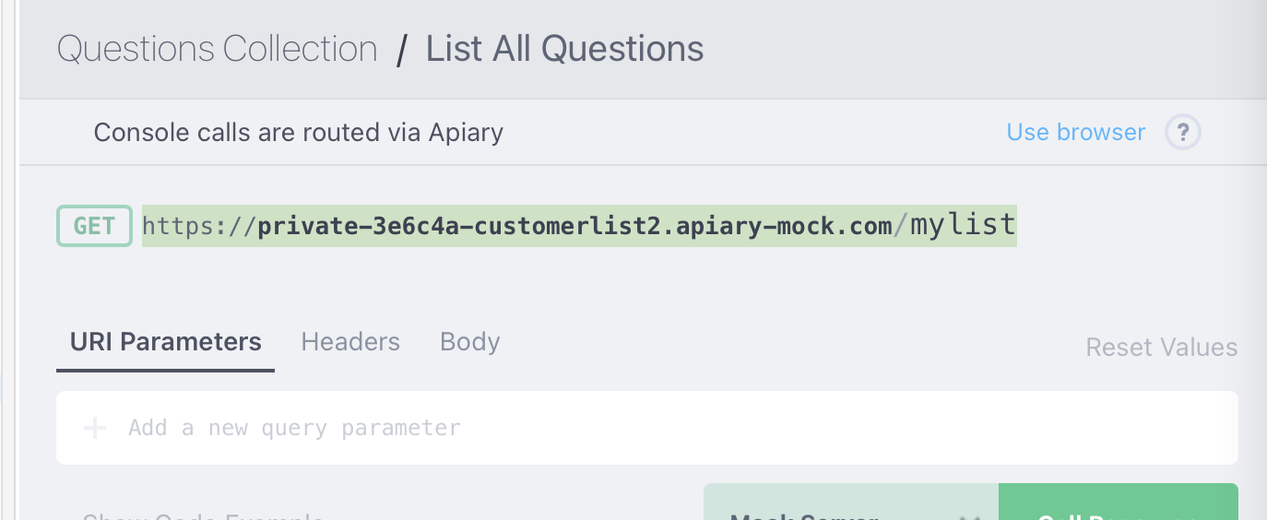

- Paste this URL on a browser window and check if the response is returned.

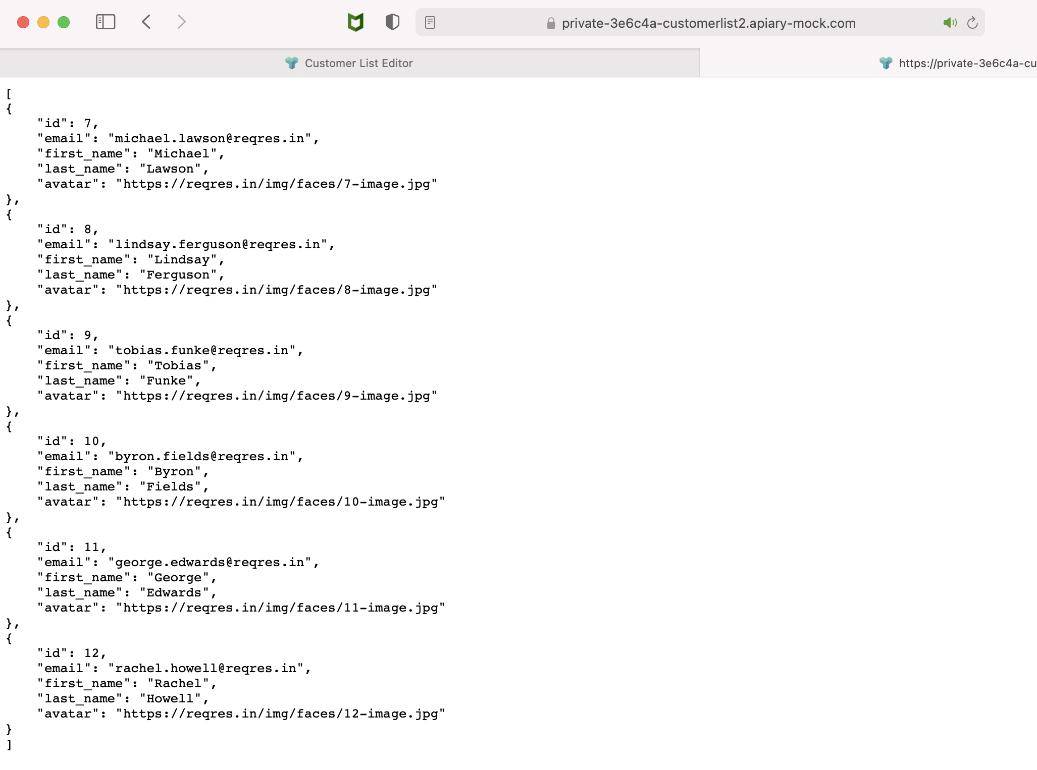

We can see that the response is being returned. This url can be used for testing purposes.

- Now we can also generate code for different languages for the given api. To do that we click on the “Switch to Example” button.

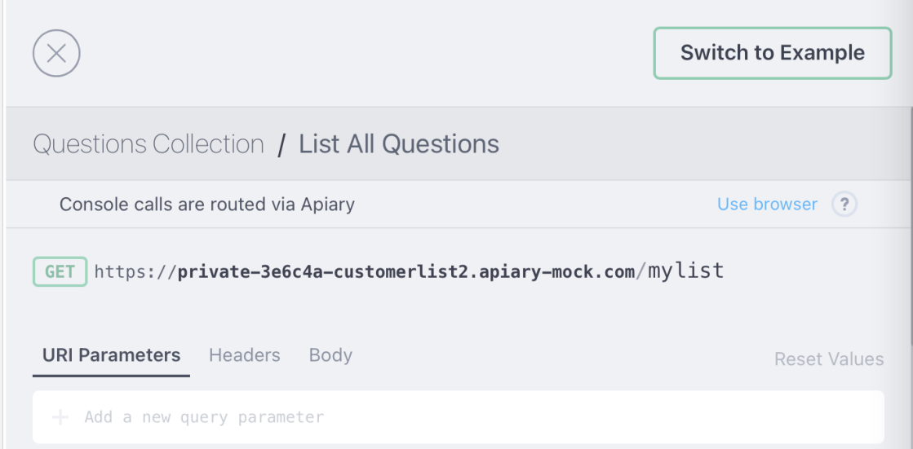

- This opens up a window where you can select the type of language support required to call the api. 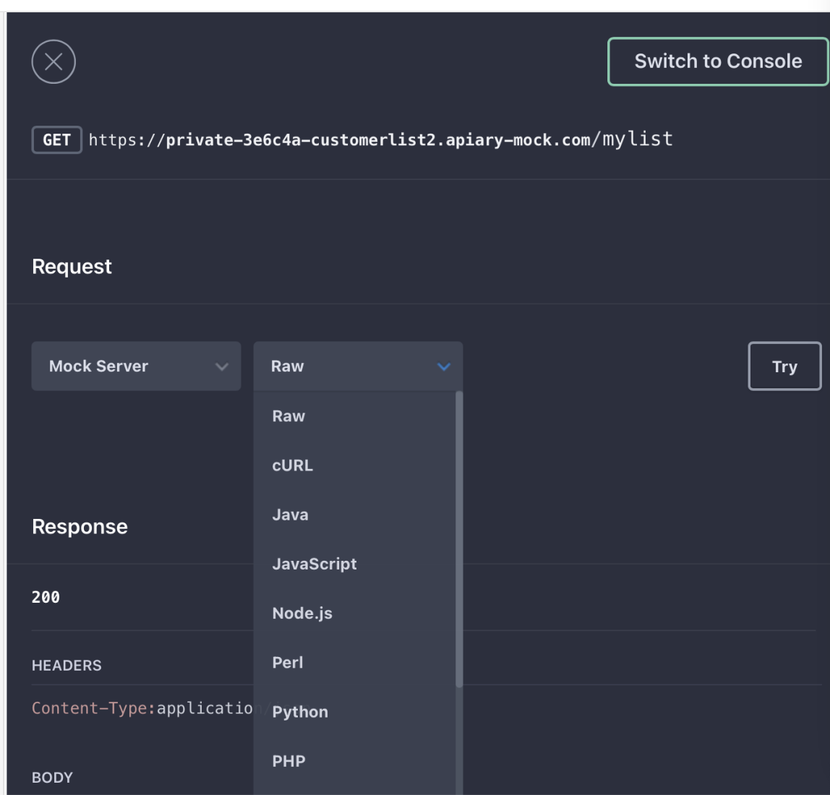

- You can directly copy the code from here and paste it into your working project.

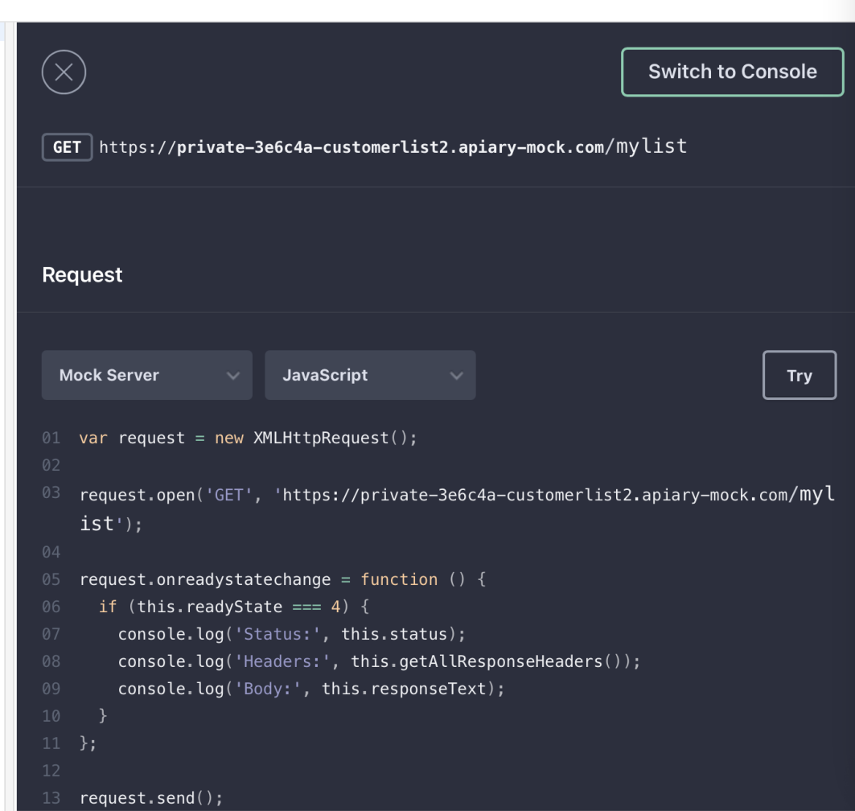

- We can click on the “**Inspector**” option on top to view the history of all calls made to this api.

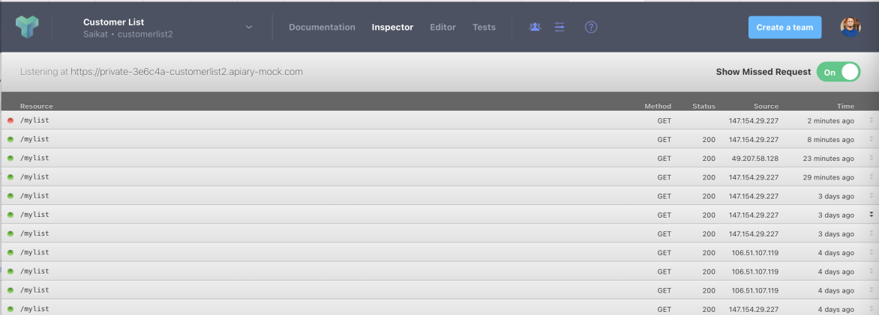

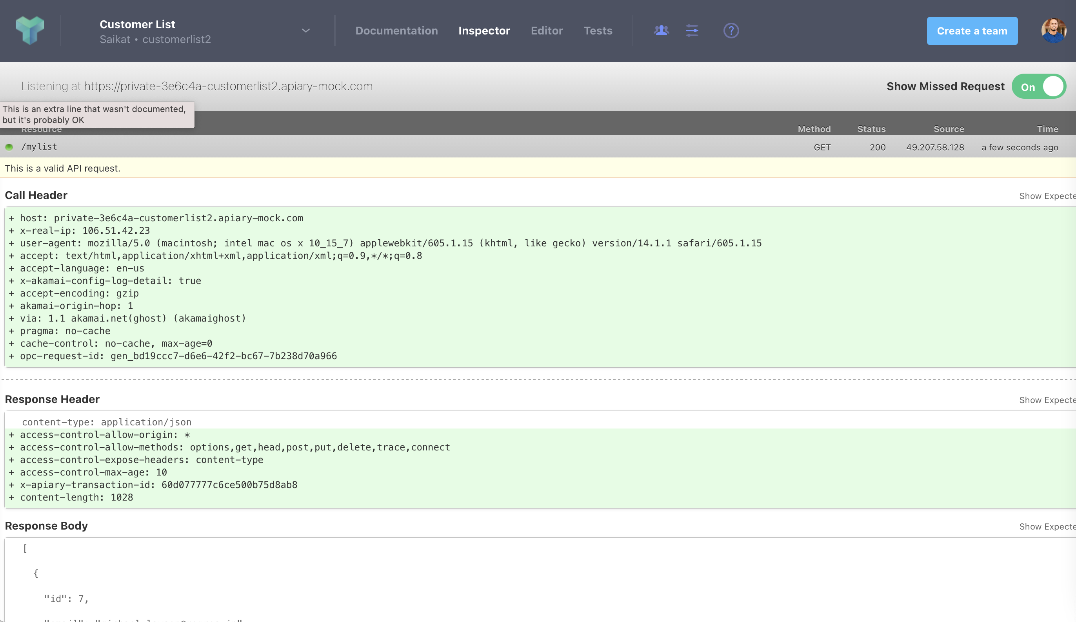

**Linking your project to Github:**

- We can link our project to Github by clicking on the “Link this project to Github” option.

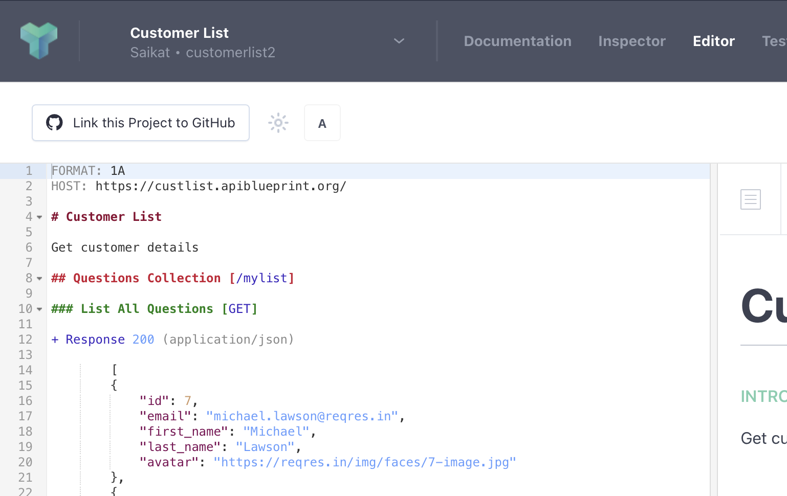

- This will take you to this Setting’s page.

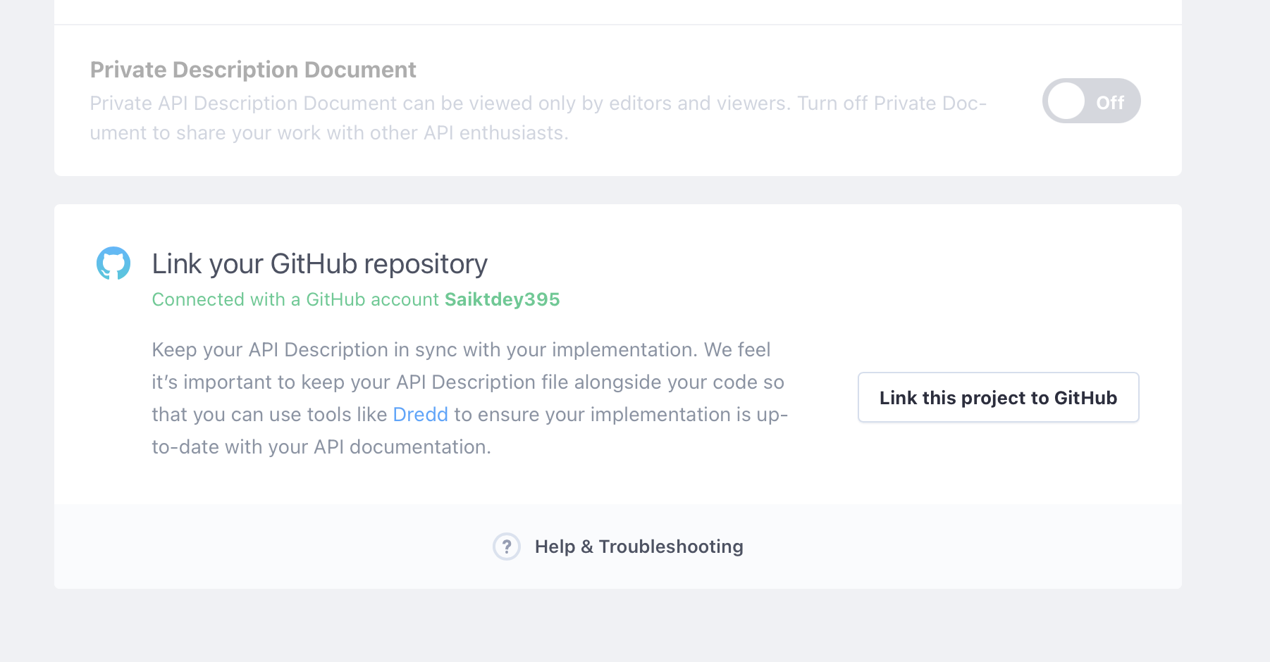

- Now before Clicking on “Link this project to Github” button. We need to make sure we have an empty repository created in Github.

- Go to Github account and create a empty repo.

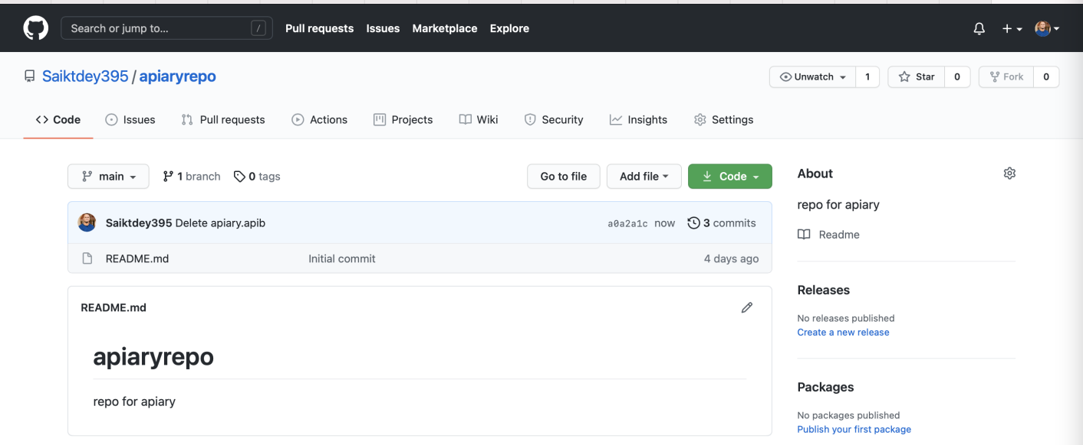

- Search for that repo in “Link your Github repo” and your git repo should be visible as shown below.

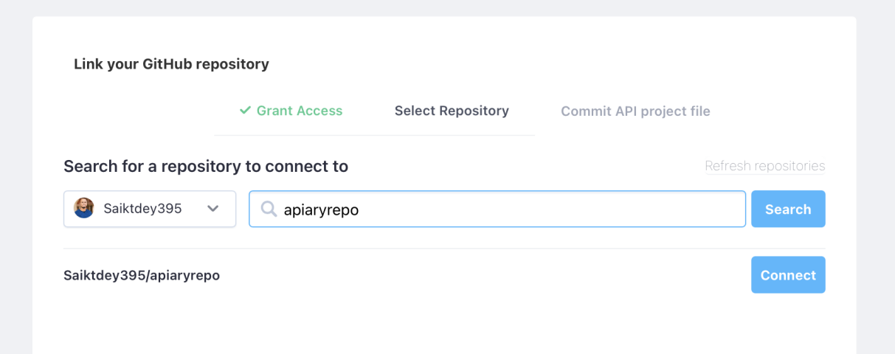

- Then we need to click on “Connect” and enter the commit message.

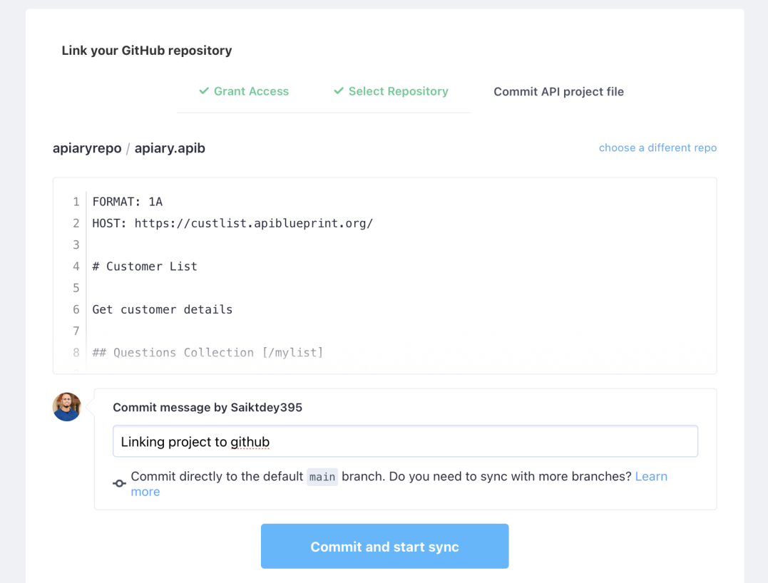

- Once done it will show a conformation like this.

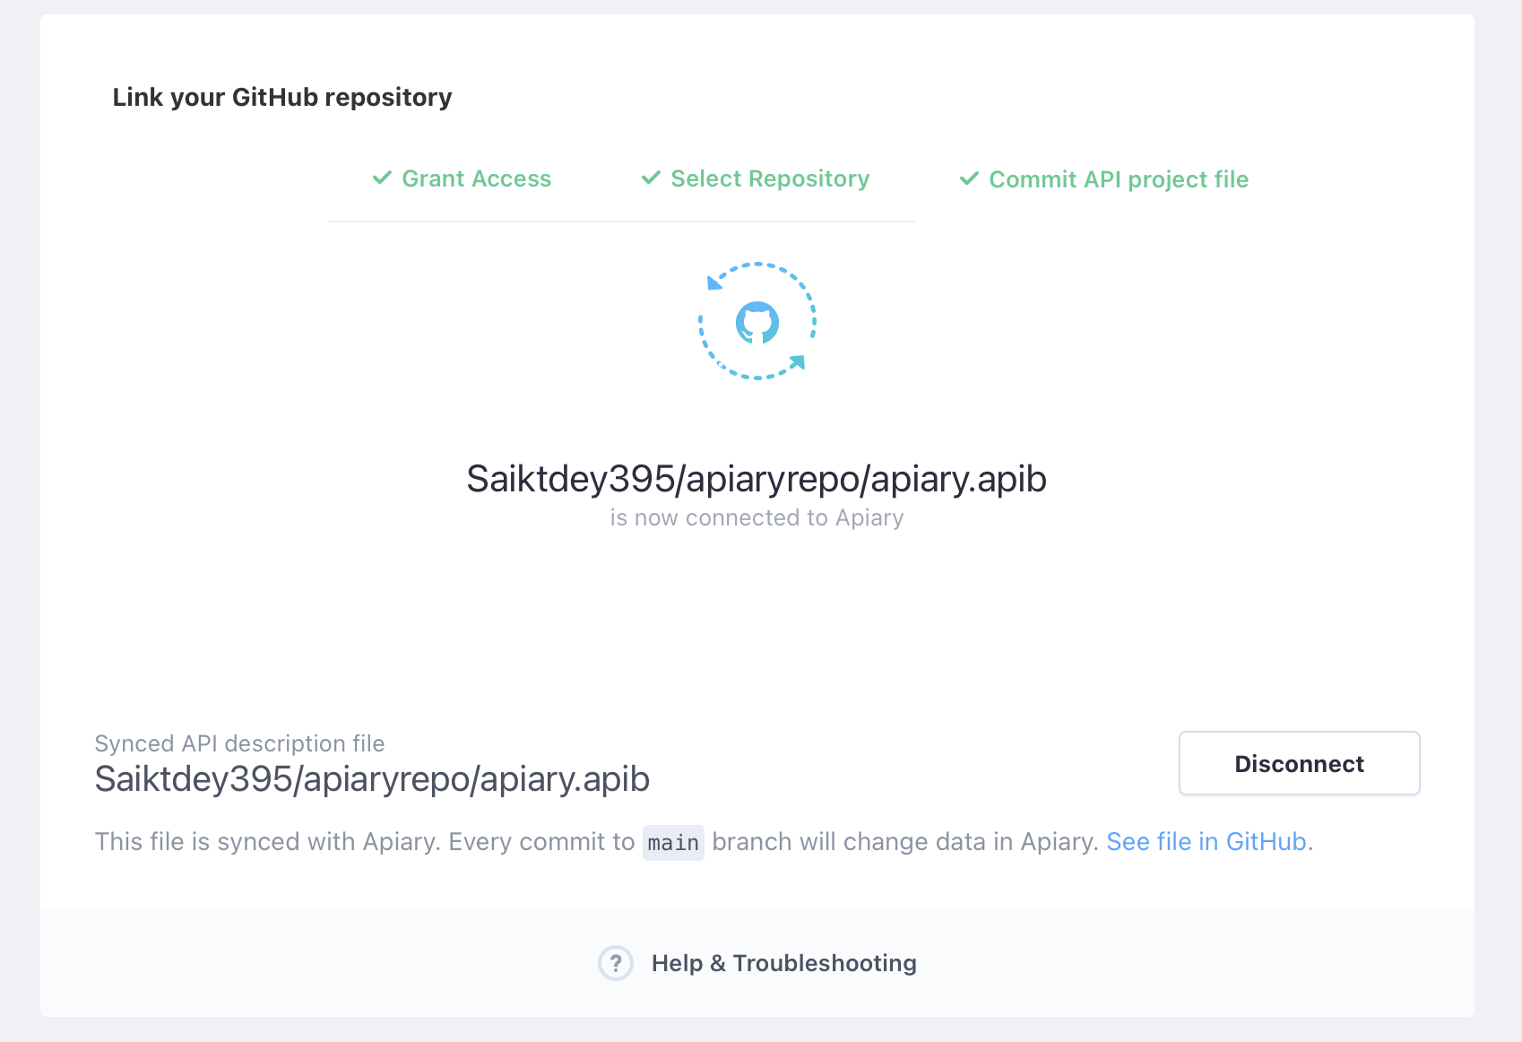

- If we now go to Github, we should be able to view our project. We can see a file called **apiary.apib**

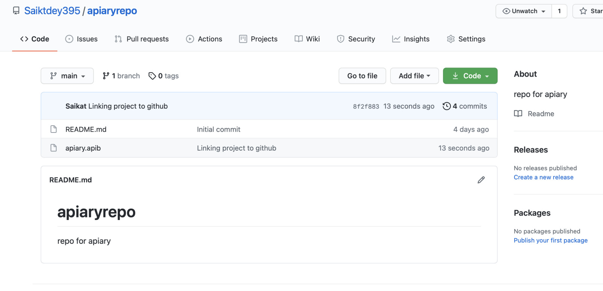

**Unit Testing using Dredd:**

To Unit Test our code with Dredd, we need to navigate to the “Test” section and then to the “Tutorial” section.

- Run the below commands as shown.

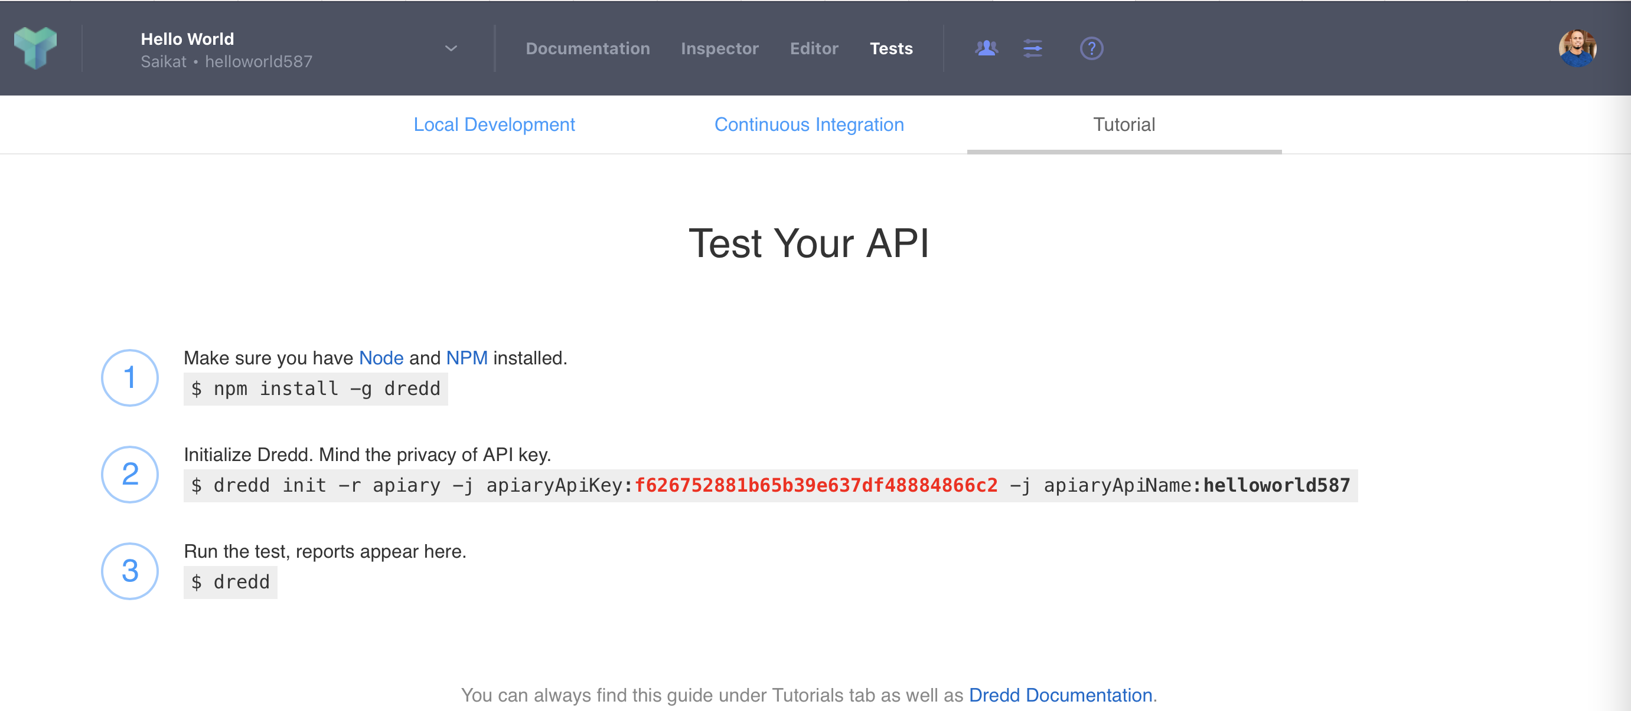

Before running these commands we need to make sure we have **node js** and **npm** installed in our system.

Screenshot from Terminal:

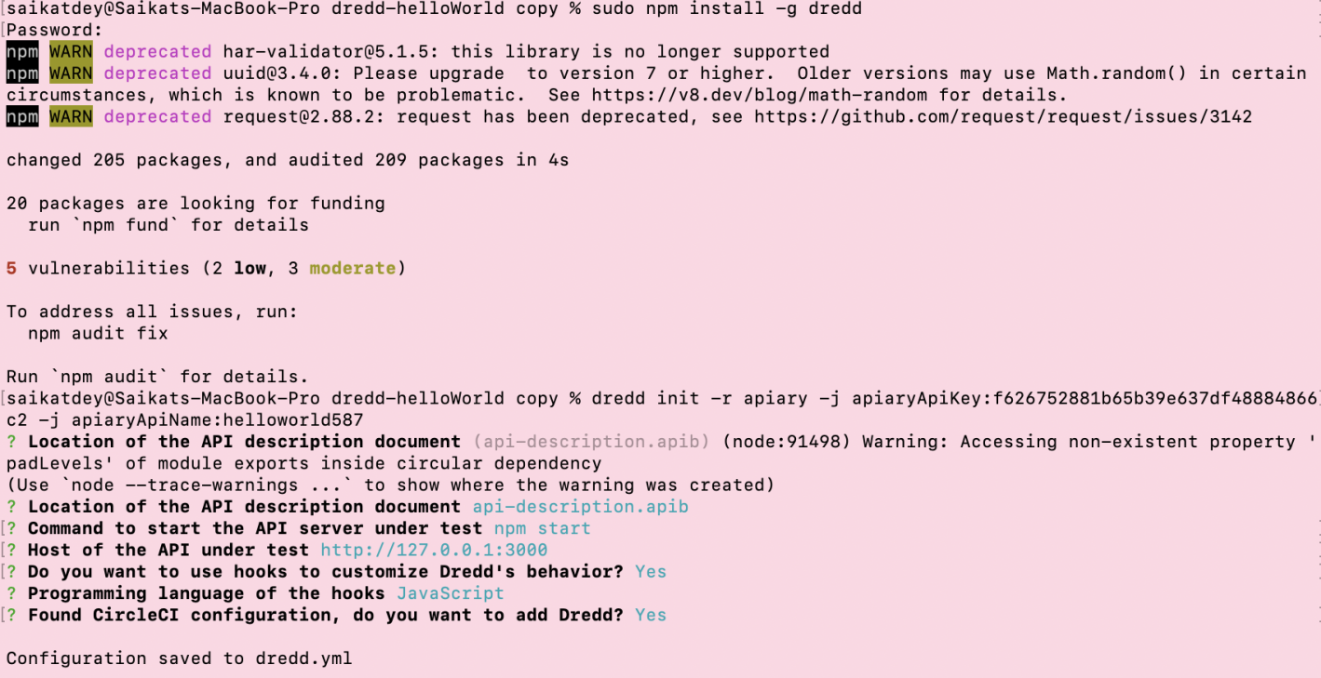

Create a file called **api-description.apib** and insert the following commands in the file.

FORMAT: 1A

# GET /

+ Response 200 (application/json; charset=utf-8)

{"message": "Hello World!"}

Now create an app.js file and paste the following code.

var app = **require**('express')();

app.**get**('/', function(req, res) {

res.**json**({message: 'Hello World!'});

})

app.**listen**(3000);

Once done run these commands:

$ npm init

$ npm install express --save

Then run

$ node app.js &

Type below command in your terminal or cmd prompt.

dredd api-description.apib <http://127.0.0.1:3000>

Ideally the folder structure would look like this after all installations:

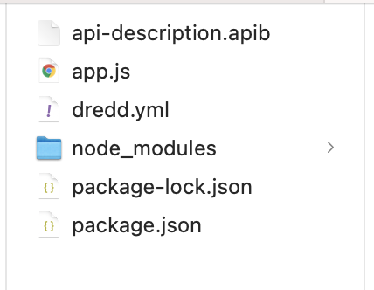

Finally type $ dredd to execute the test case run.

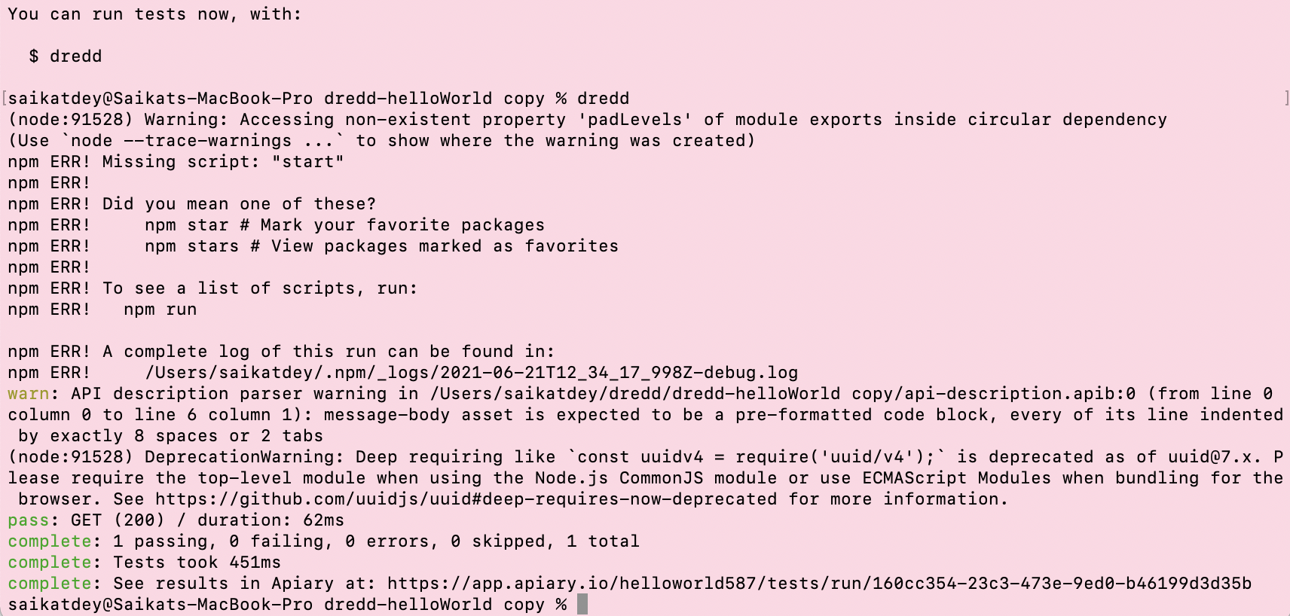

Above we can see that the test case has passed.

Now, If we navigate to the apairy page we can see that the test case has passed and the required details as displayed.

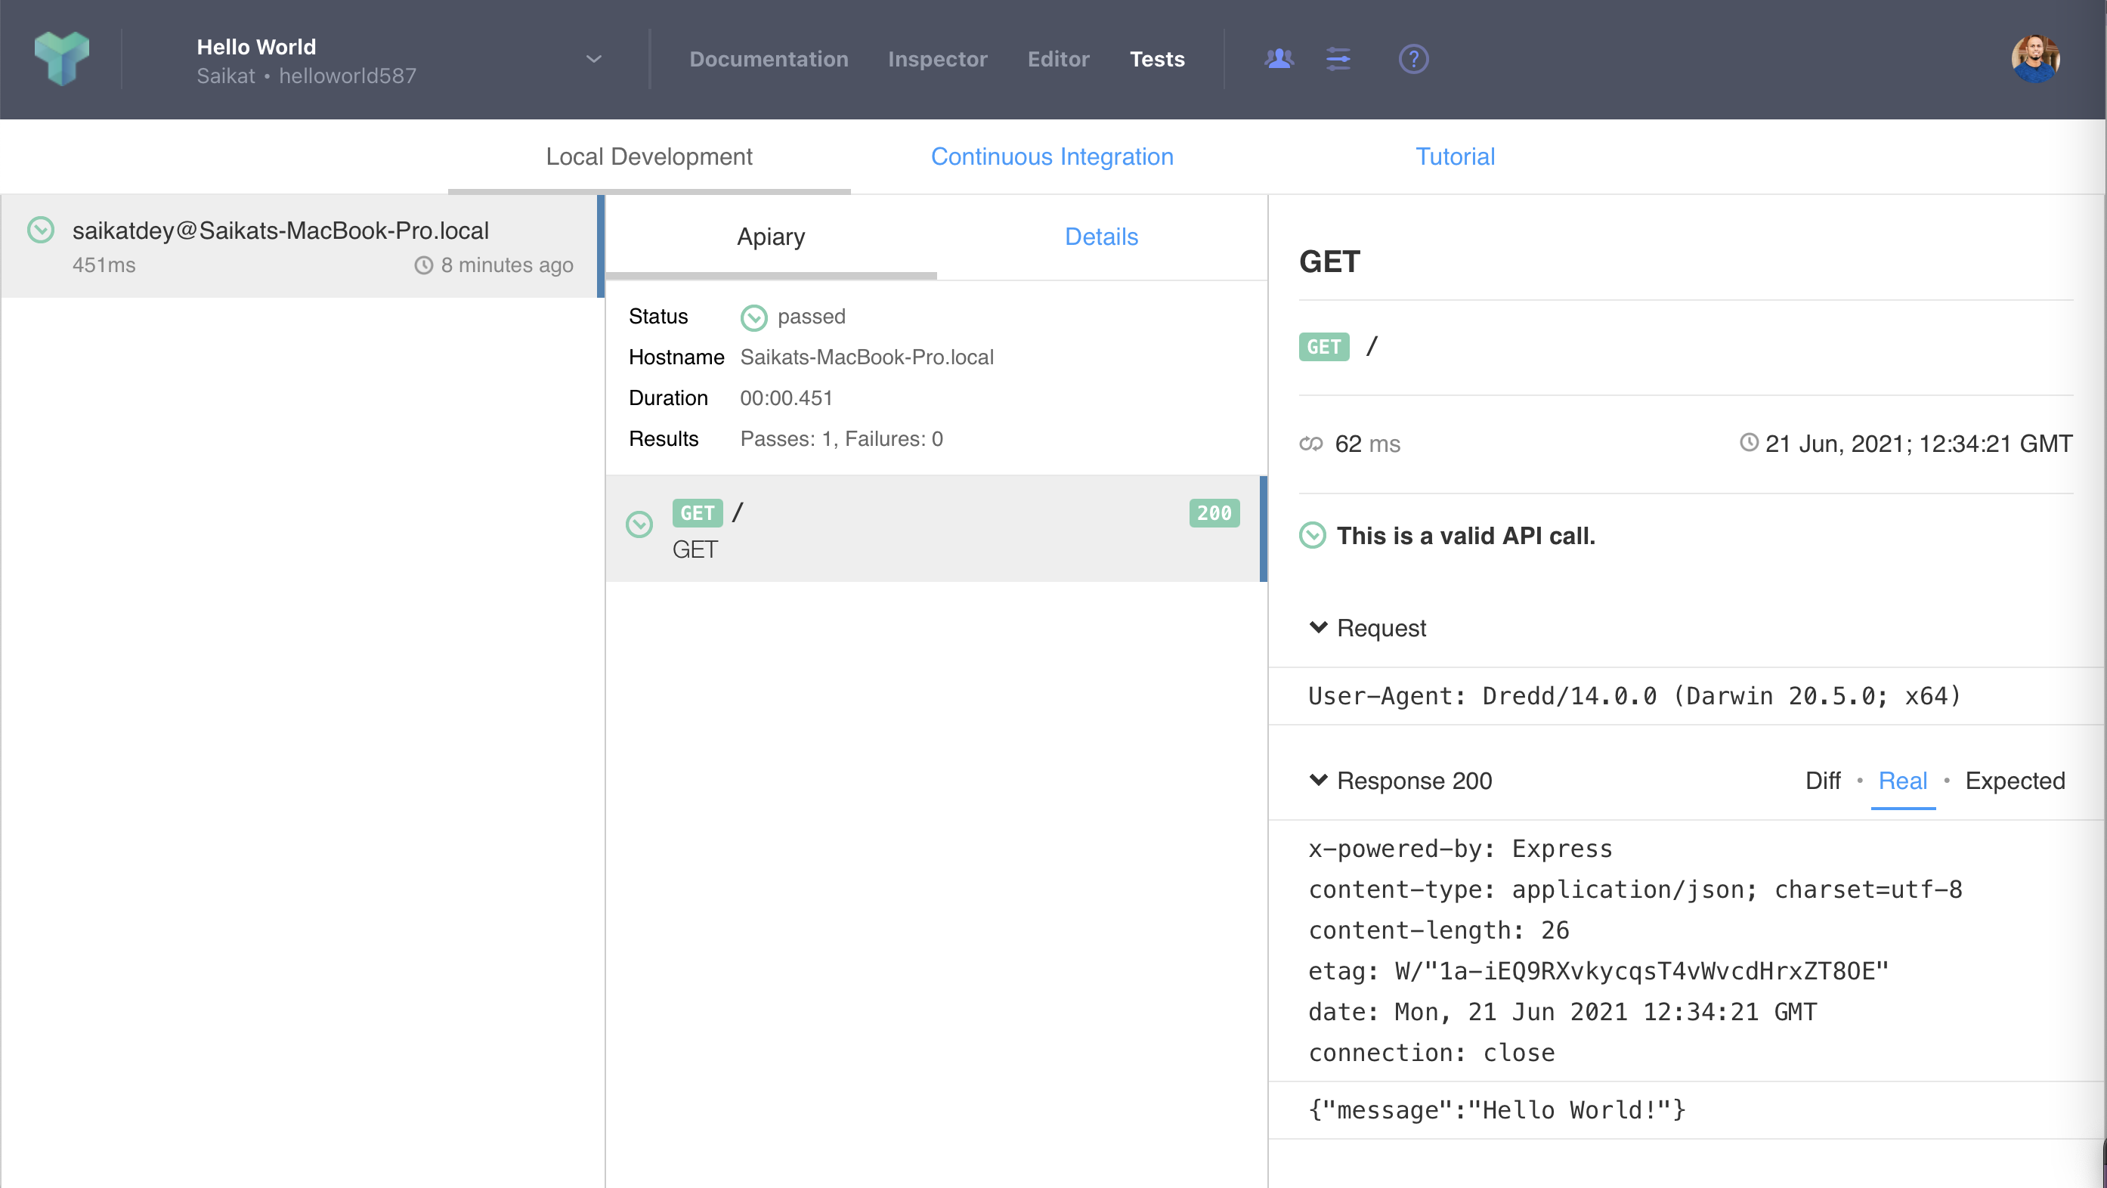

Please follow this link for more info on dredd installation: <https://dredd.org/en/latest/quickstart.html>

To know more about APIARY please follow below links:

APIARY Help Page:

<https://help.apiary.io>

API Blueprint Tutorial:

<https://help.apiary.io/api_101/api_blueprint_tutorial/>

Learn about Markdown language:

<https://help.apiary.io/api_101/mson-tutorial/>

Continuous Integration in APIARY:

<https://www.ateam-oracle.com/continuous-integration-with-apiary-dredd-and-wercker>

<https://help.apiary.io/tools/automated-testing/testing-ci/>

----x----